**Binary Search Trees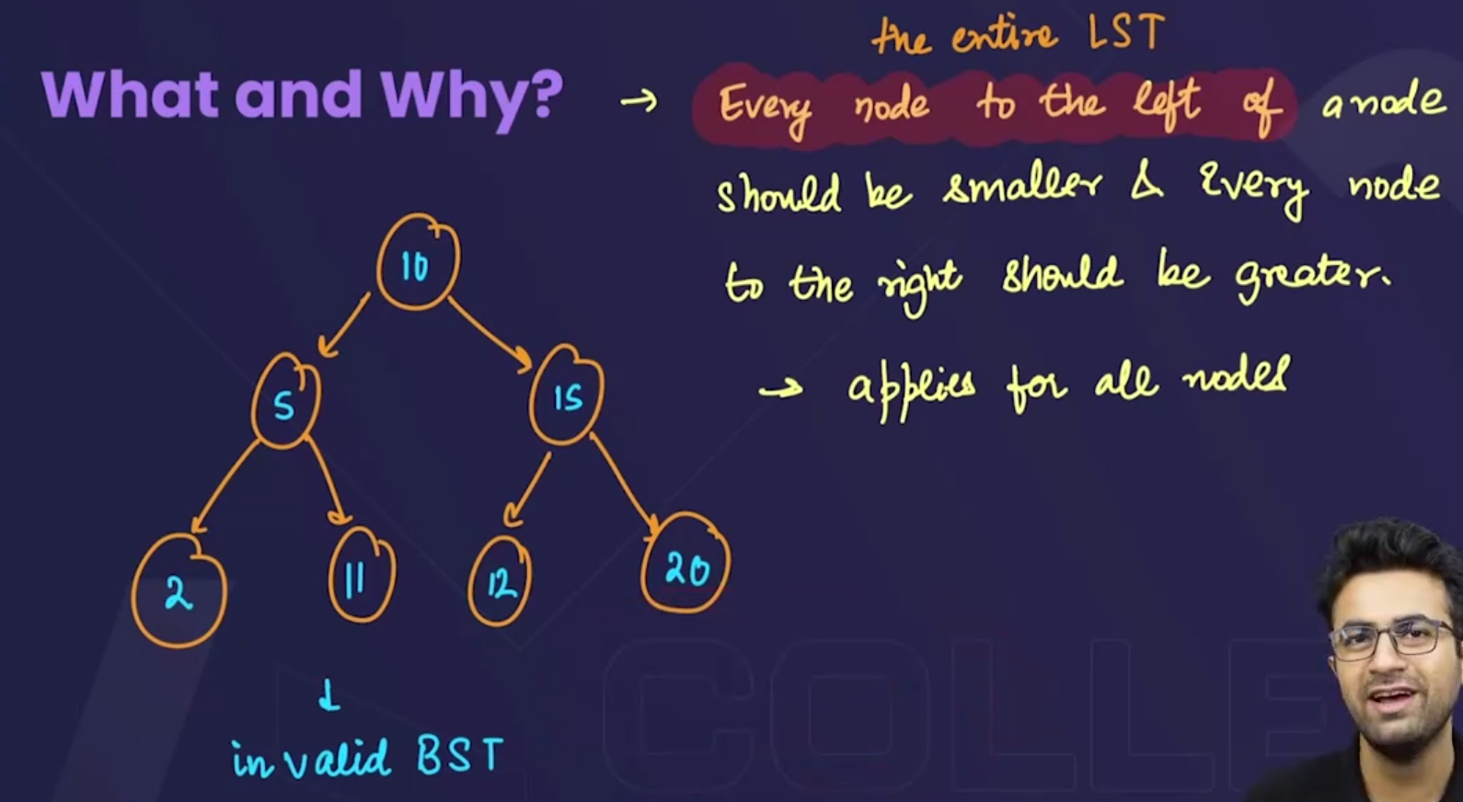**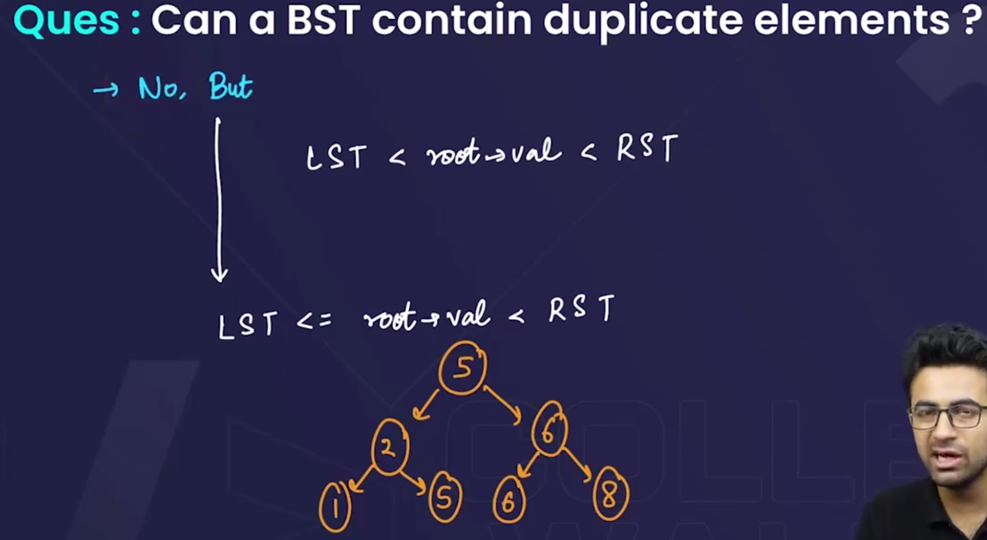

* In general, the **binary search trees** don’t have a duplicate element. But sometimes in question the definition of binary search trees is given that elements in the left or right can be equal to the root element.

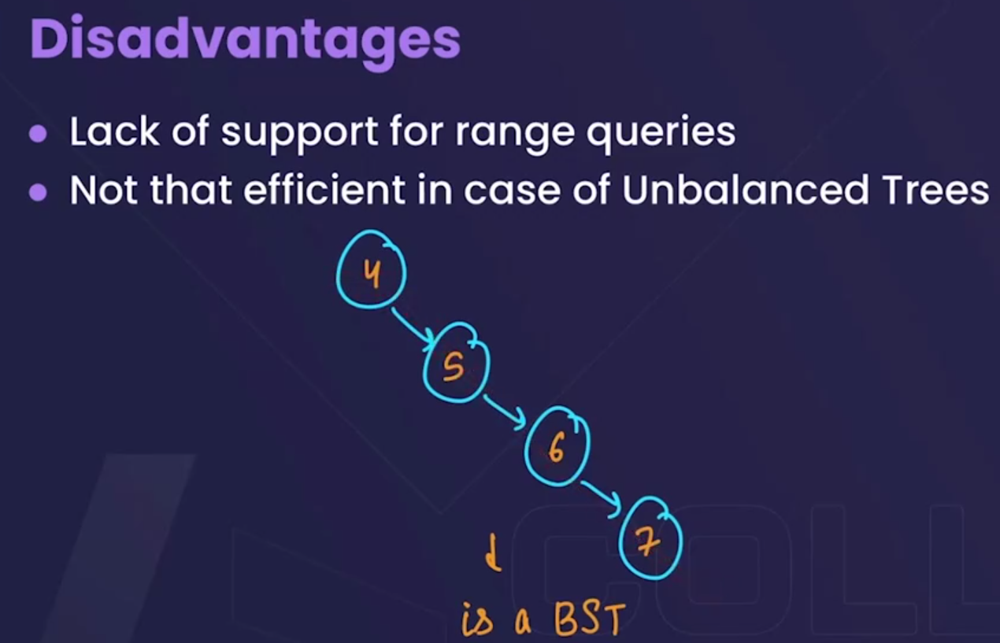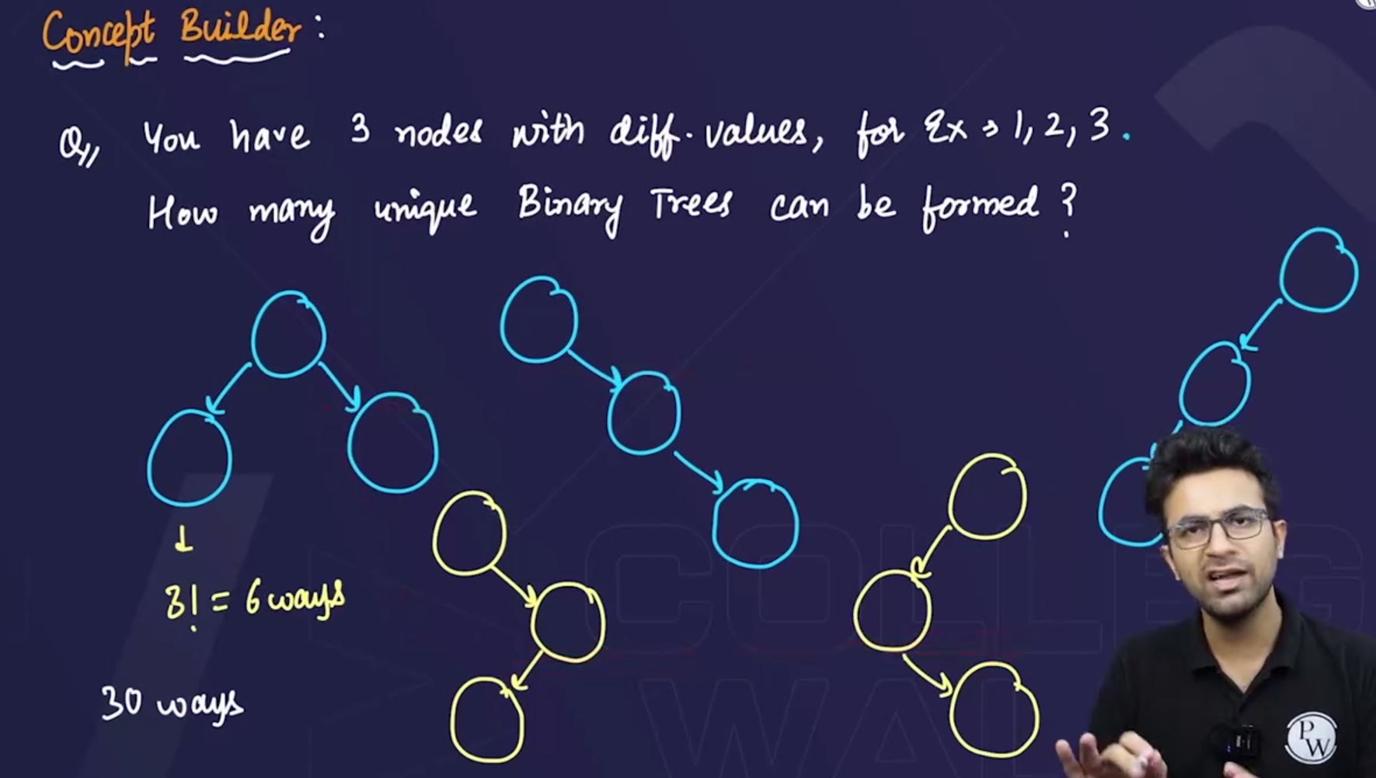

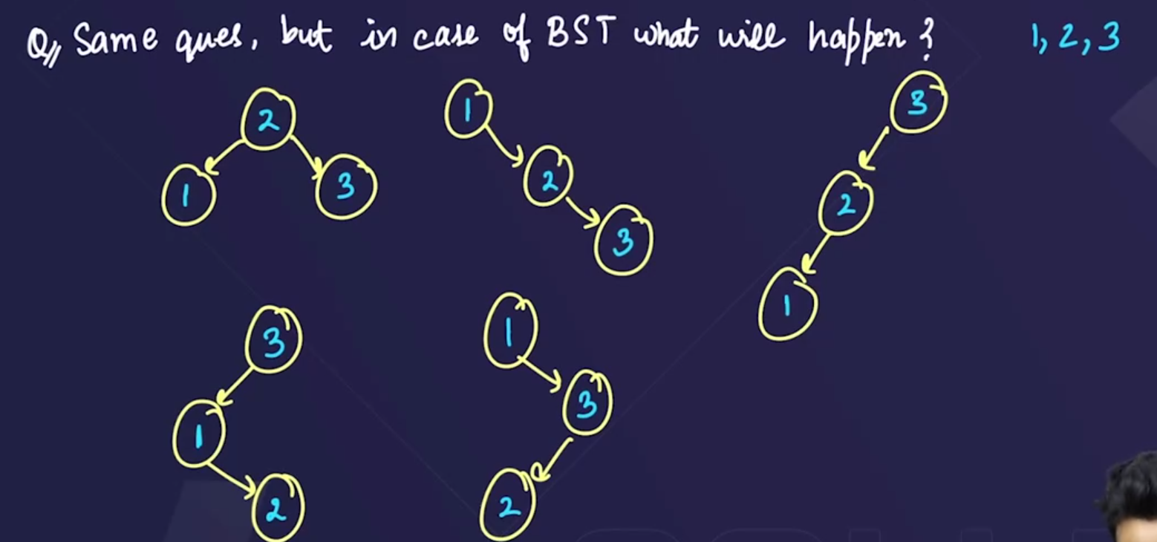

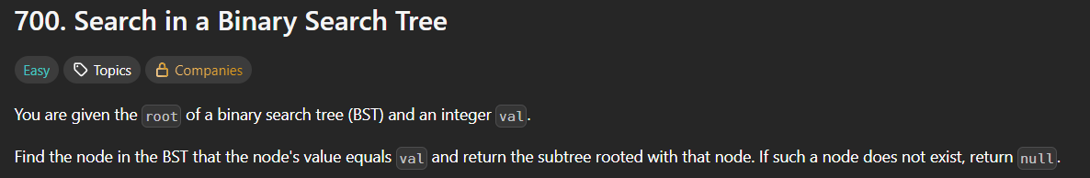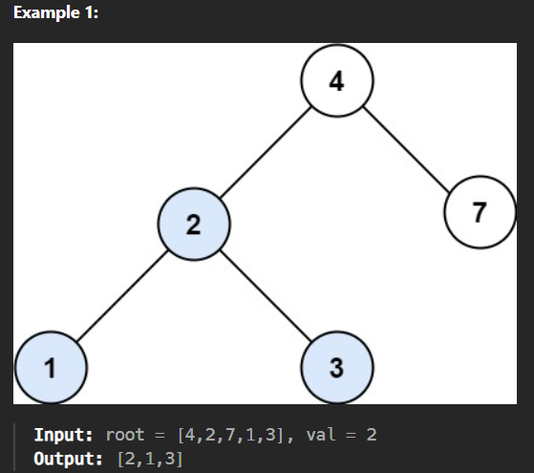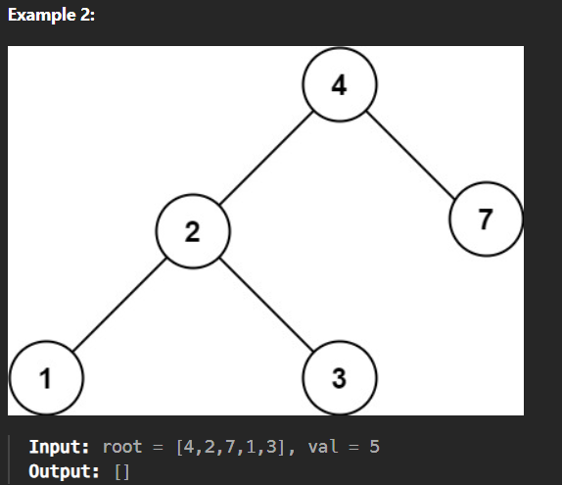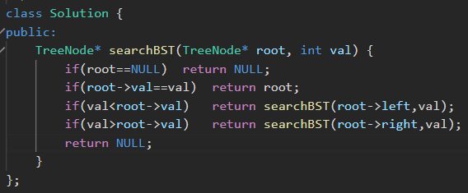

* For above question(to search in a BST):

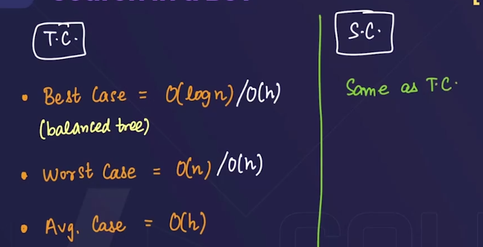

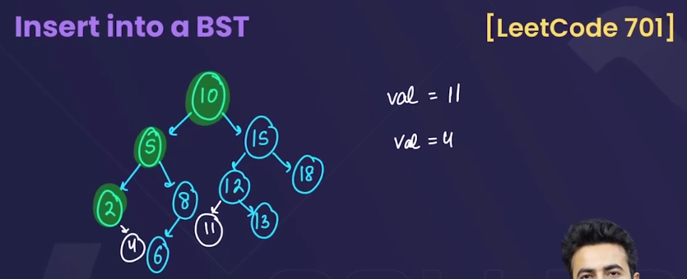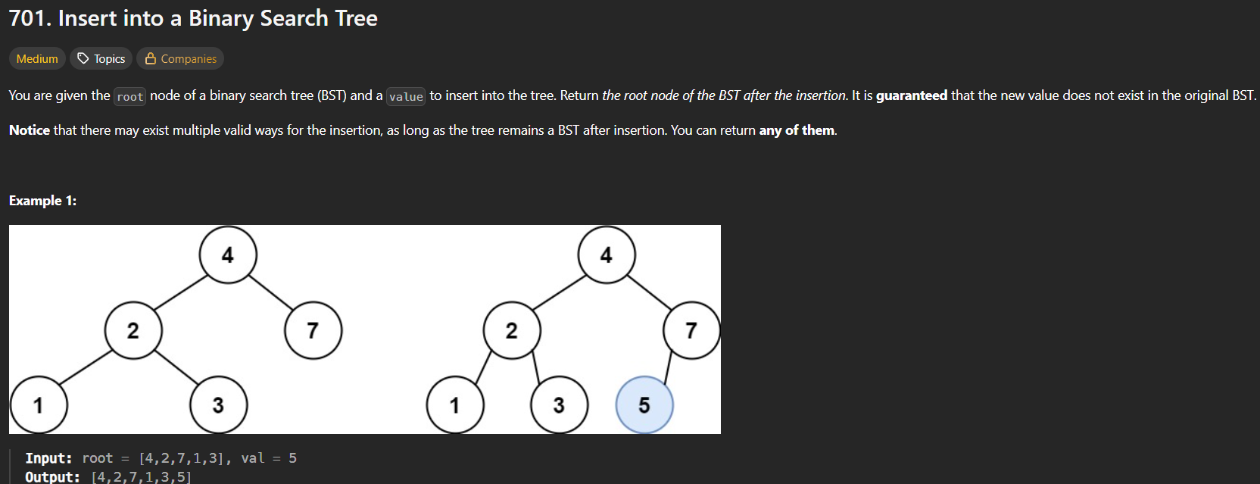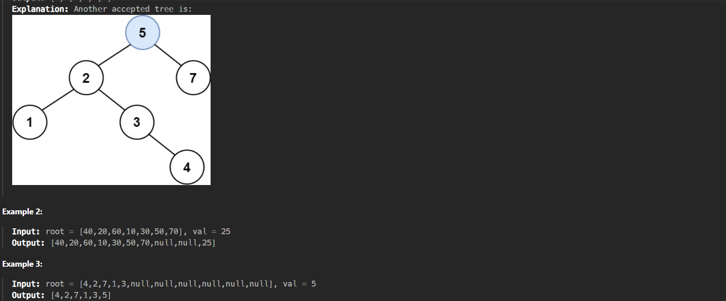

* 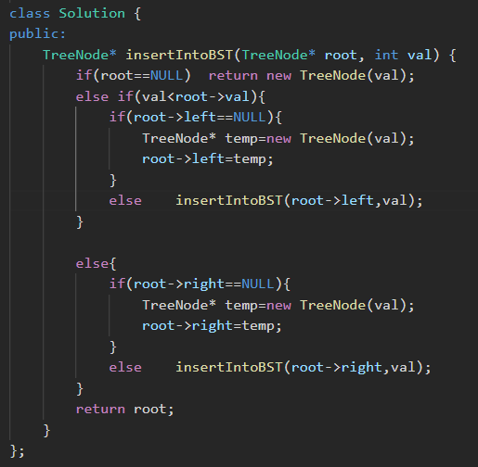

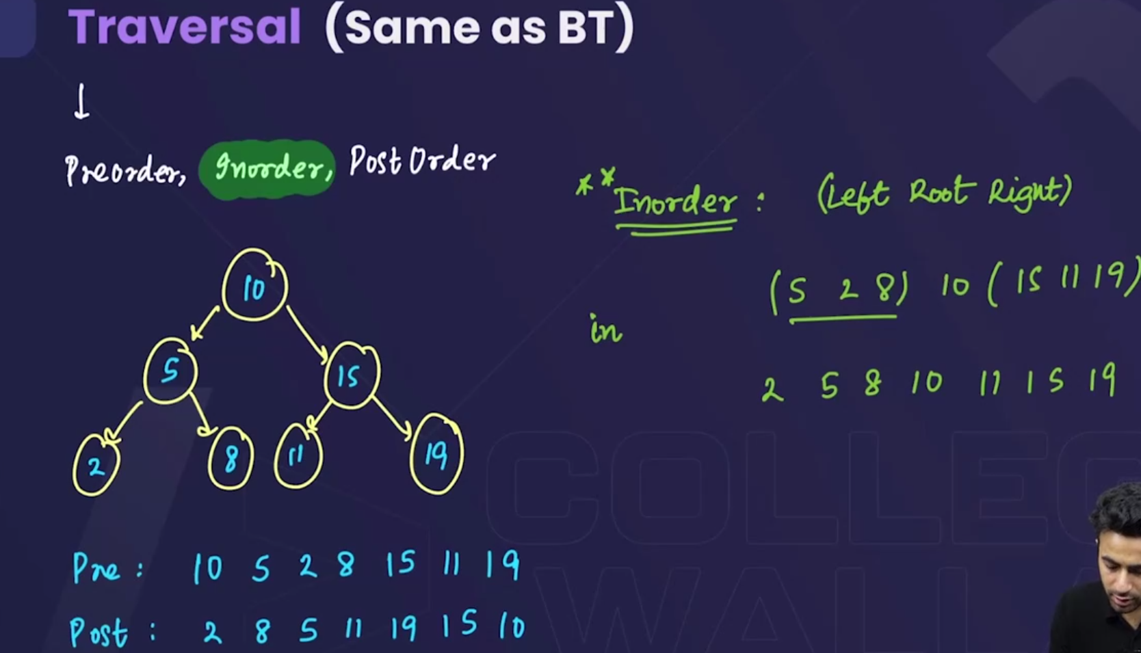

* 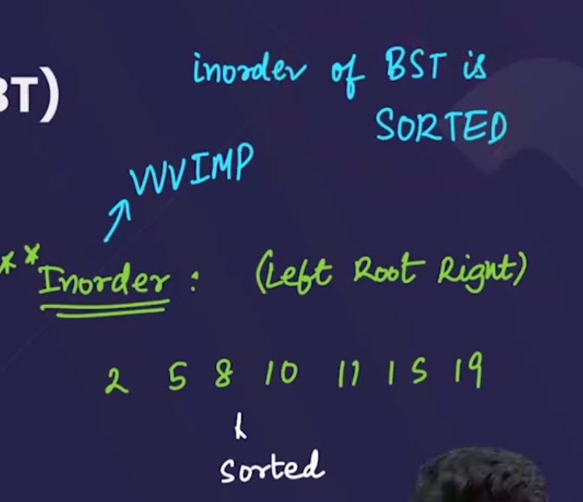🡪**The inorder traversal of BST is an sorted array🡪very important**

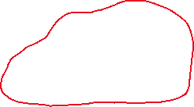

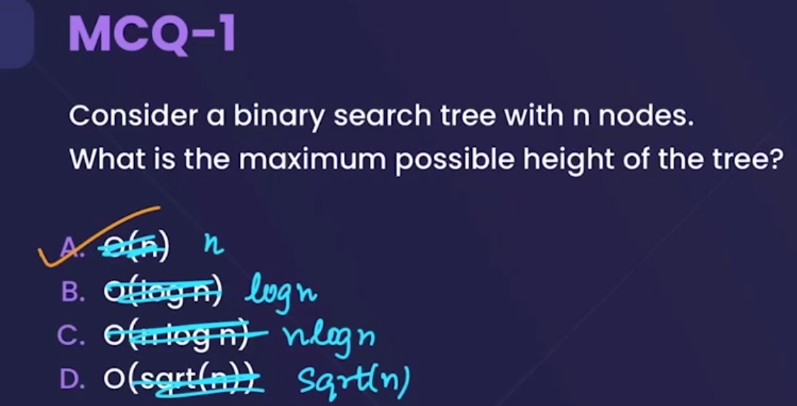

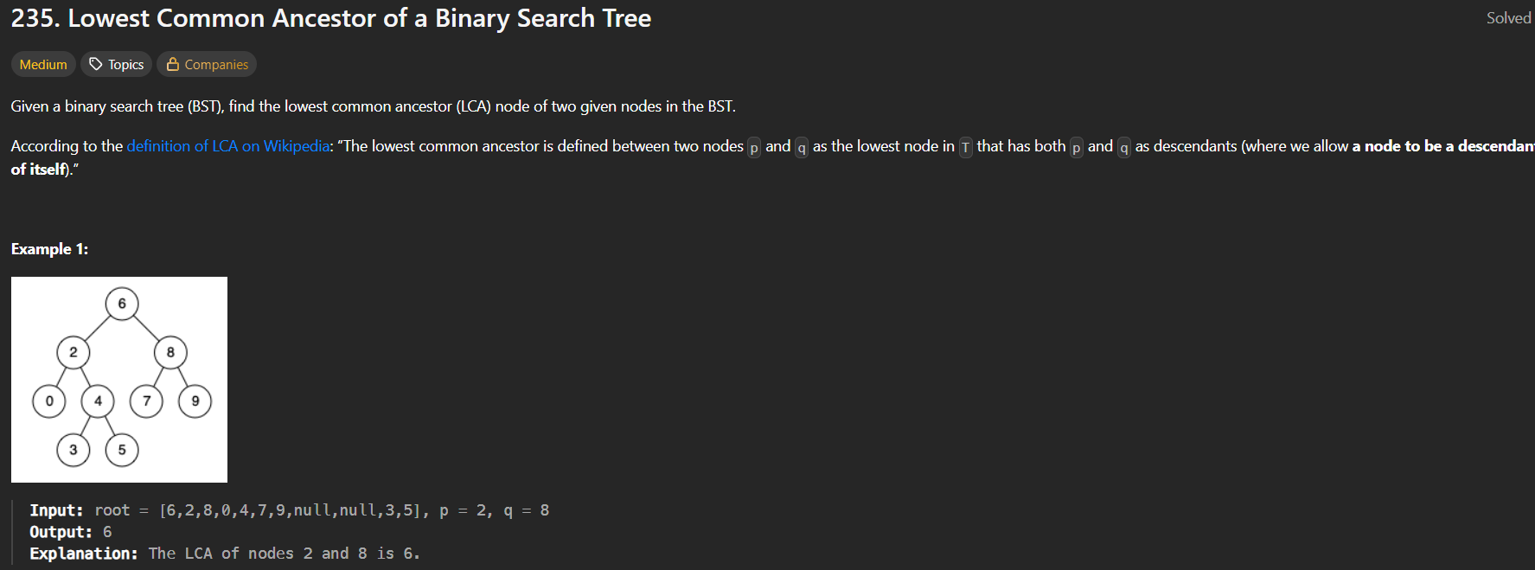

* This question is similar to “least common ancestor of binary tree” (leetcode 236), and the same code of that question can be used here without any changes🡪but that is not an optimal solution for a binary search tree. 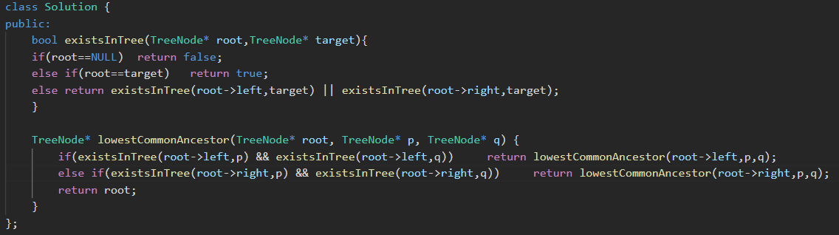
* Optimal solution: 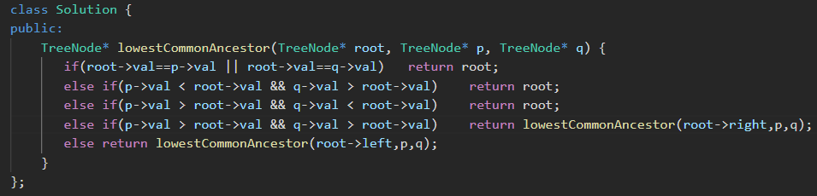



* After combining above 3 steps: 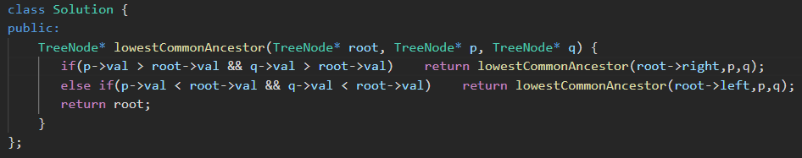



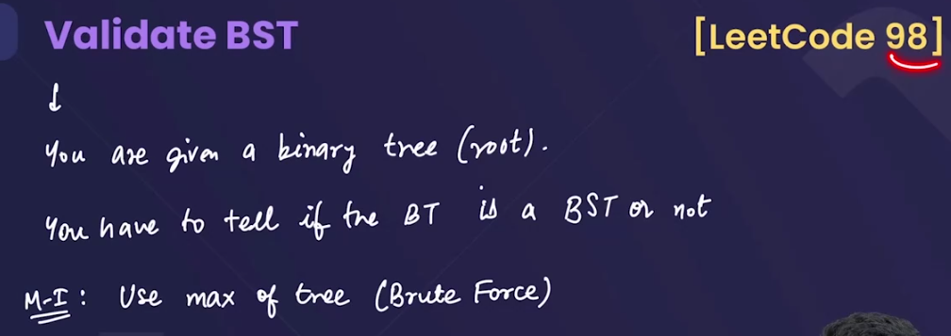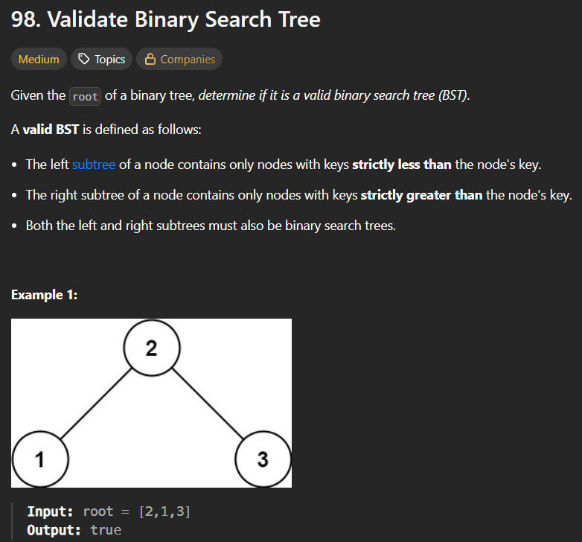

Method 1🡪 Bad method (Brute force)🡪T.C=O(n)

* 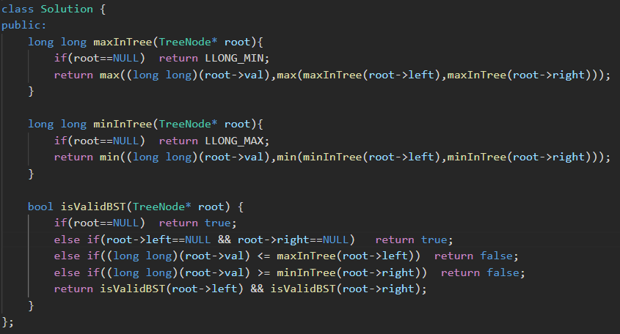
* pehle pta krlo ki left subtree m jo sbse bada value h, usse root ka value bada hona chahiye, similarly, right subtree m jo sbse chota value h, usse chota hona chagiye root ka value, and similarly check for each node.

Method 2🡪using preorder traversal🡪we know that the preorder traversal of a Binary search tree is a sorted array-🡪**very important point**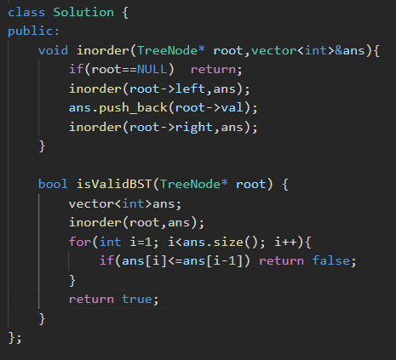

**Method 3🡪without using extra space (vector)** 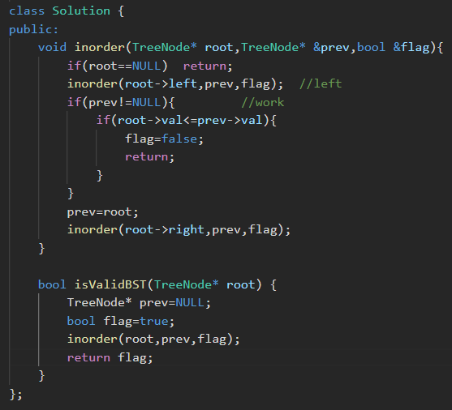

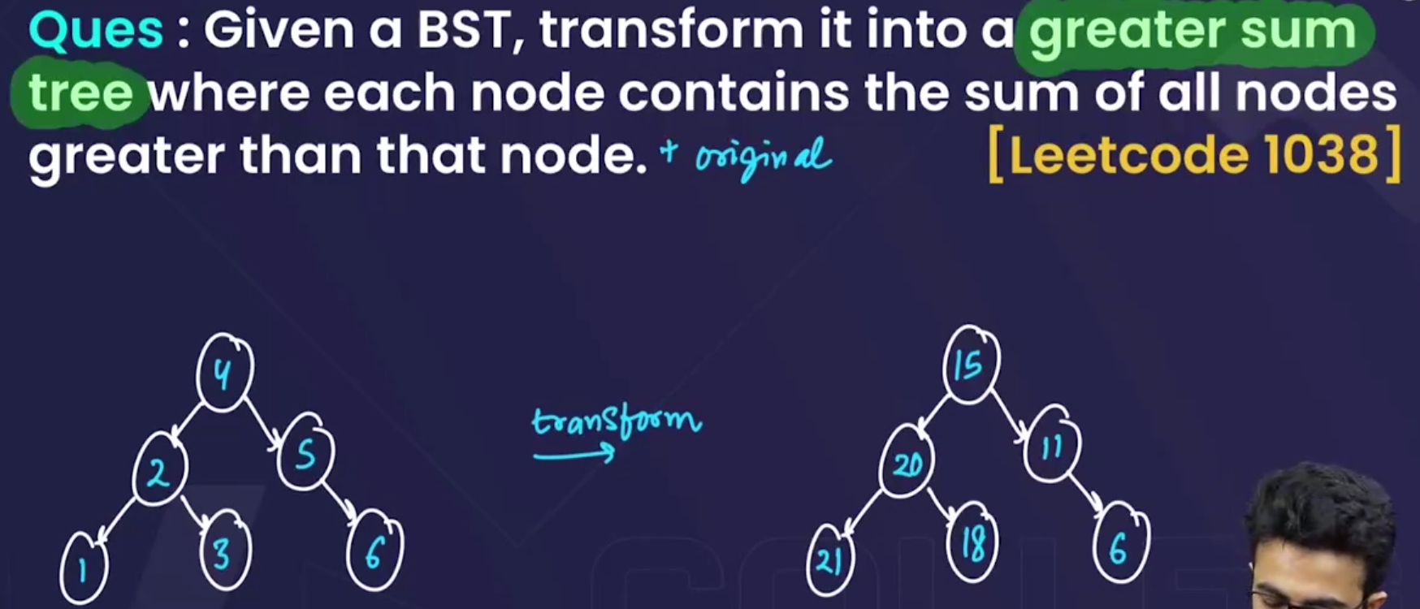

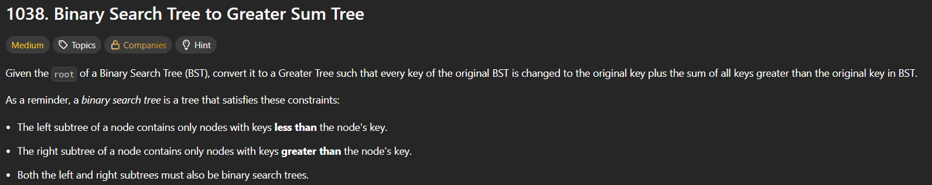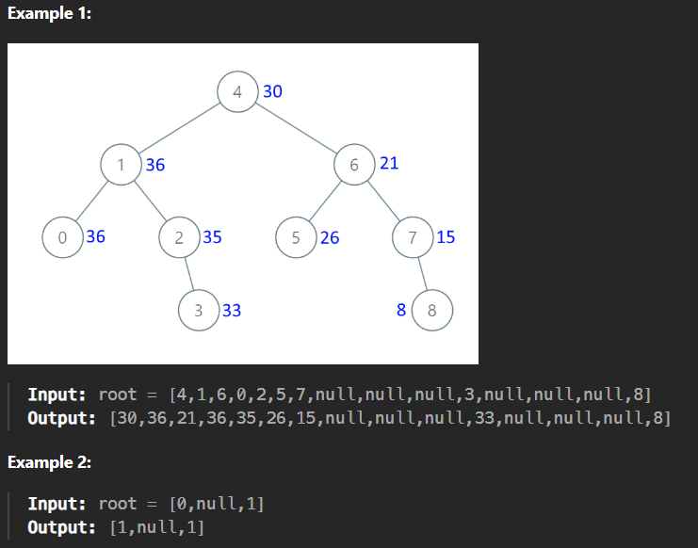

* Algorithm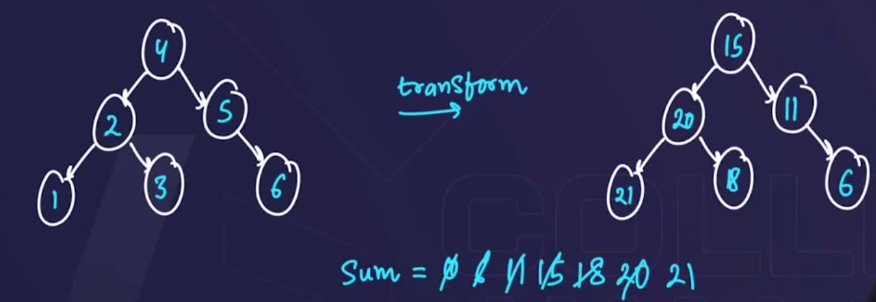

🡪since we know that , in BST, agar hm inorder use kre then, we get a sorted array, but agar hm ulta inorder use krenge then, we will get the array sorted but in descending order.

🡪so here we will make a variable, sum=0, and start from the last and currentNode+sum se each node k value ko replace krte jaayenge.

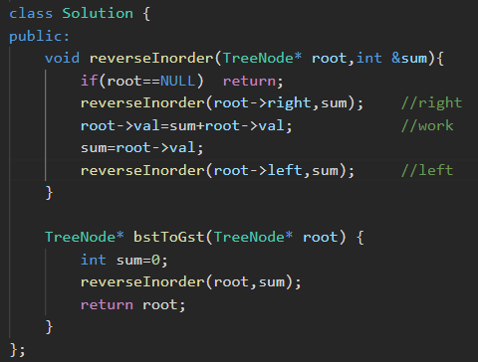

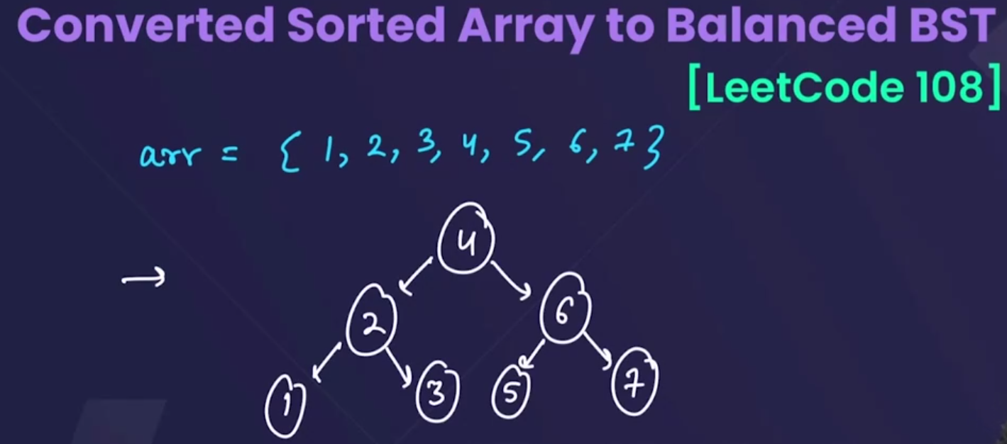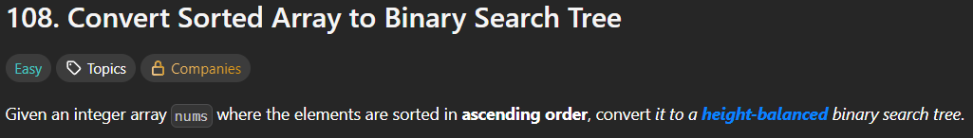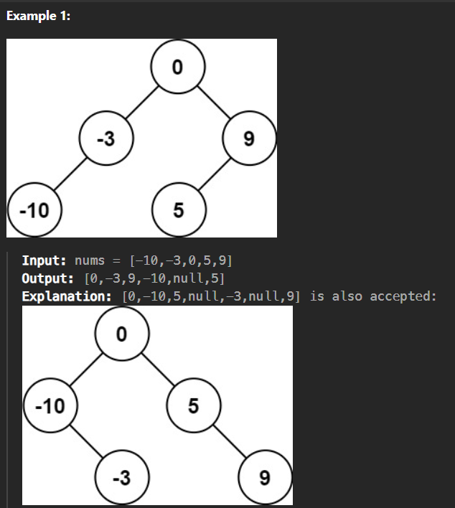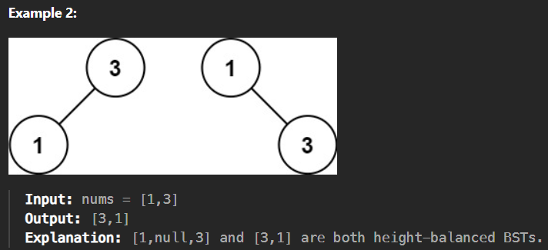

* Use Binary search Algorithm

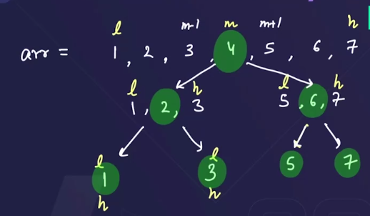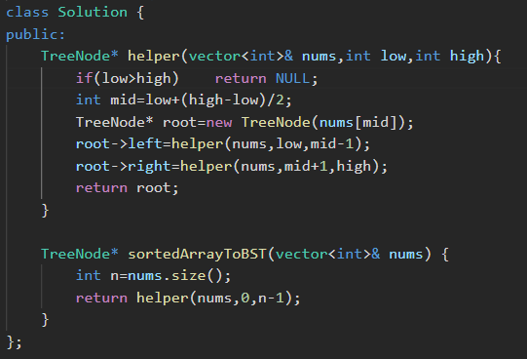

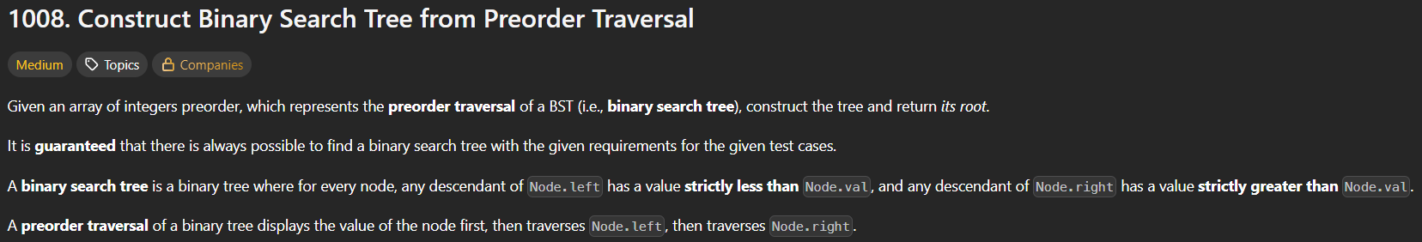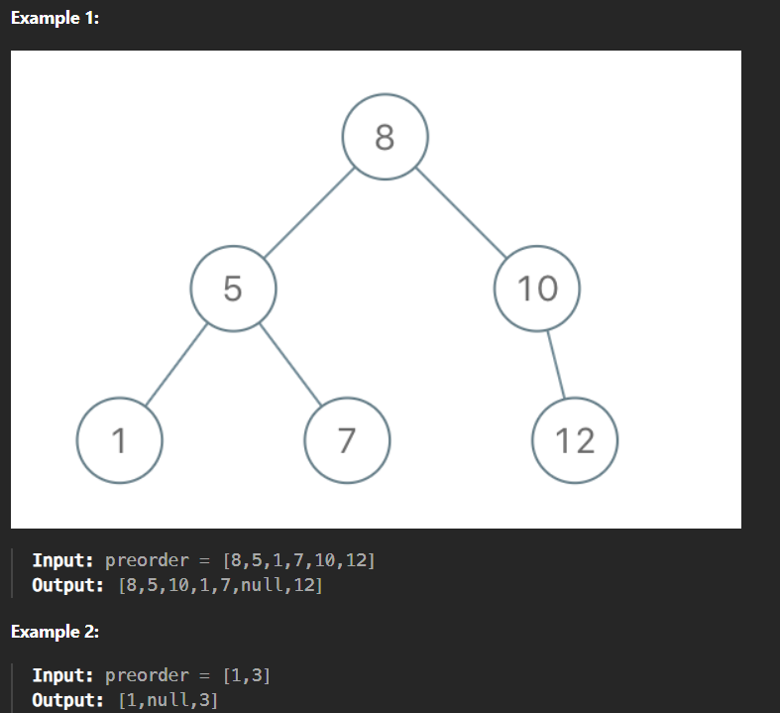

* Method 1:🡪since we have learnt how to construct a binary tree when both inorder and preorder are given, so here also we can use the same code:
  + Since here only preorder is given, we know that in BST, **the inorder traversal of tree is sorted, so if we will sort the preorder, then we will get the inorder traversal.**
  + So, now we have both inorder and preorder🡪contruct BST now.—Just copy paste the same code of Leetcode 105(construct Binary tree from inorder and preorder). 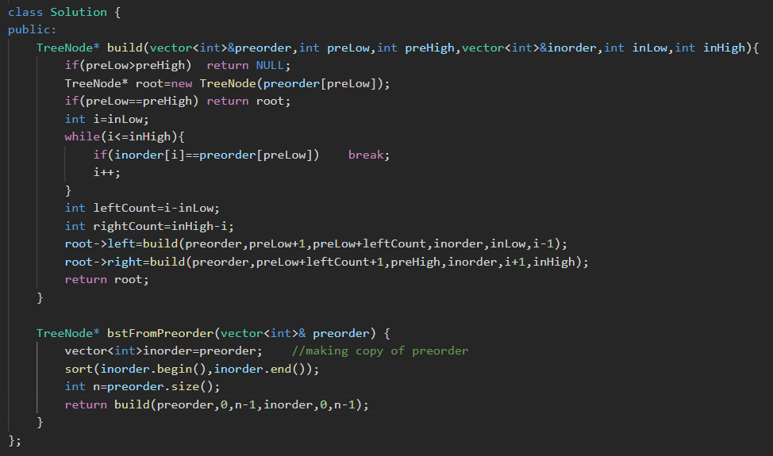
* Method 2:🡪from a preorder, an unique BST is generated. 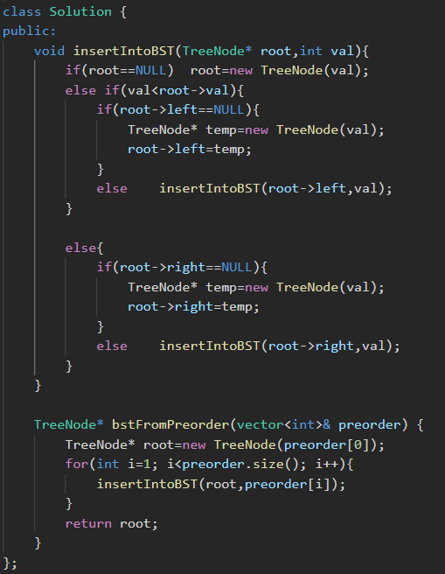

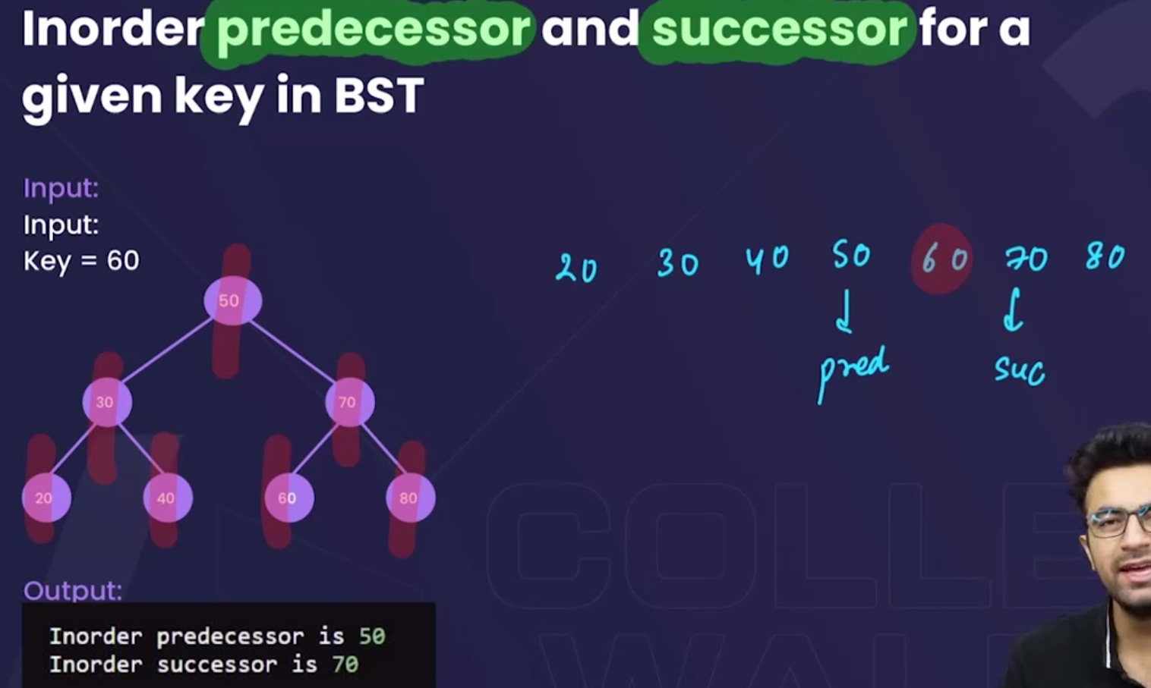

* Method 1:To print the inorder predecessor or inorder succesor, for any key then, find the inorder travesal, then make a vector and push the elements into vector, then key k ek aage and ek peeche waala value will be the successor and the predecessor.
* Method 2:🡪Shortcut
  + For prdecessor🡪ek baar left m jaoo, and then right m tb tk jaoo jb tk jaa skte ho and jb right m null aa jaayega then that will be the predecessor

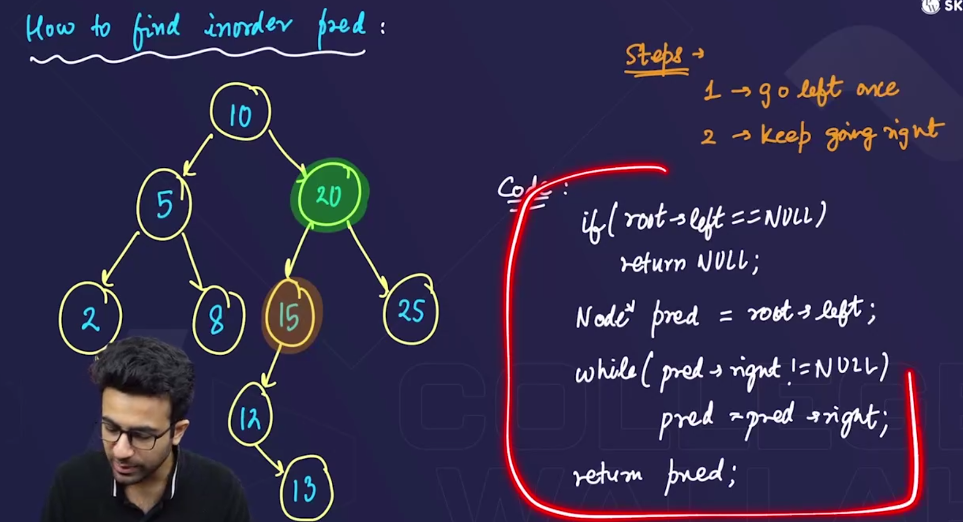

* + For successor🡪ek baarright m jaoo, and thenleft m tb tk jaoo jb tk jaa skte ho and jb left m null aa jaayega then that will be the successor.

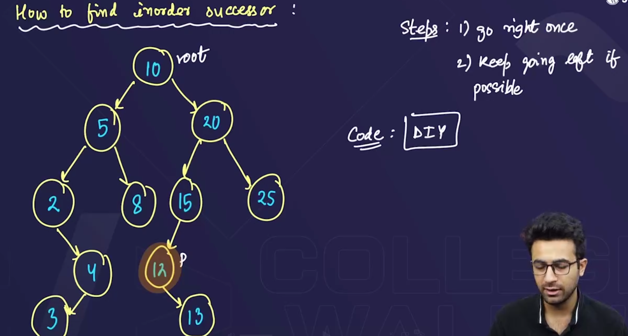

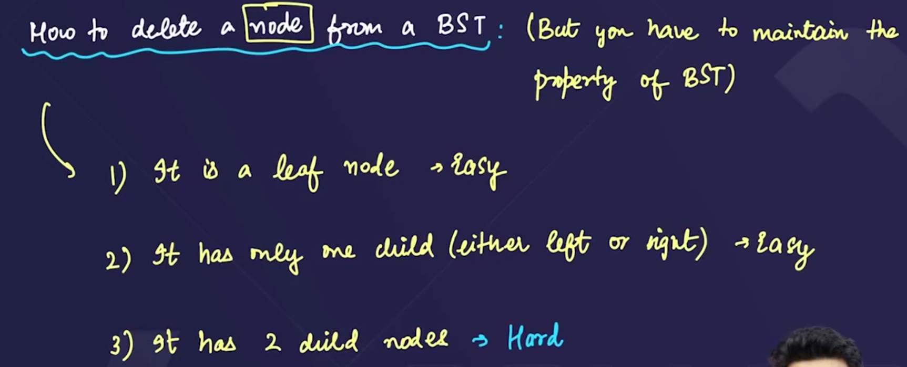

* To delete a node from the BST, have 3 cases:
  + The node that is to be deleted is a leaf node i.e have 0 child🡪easy case
  + The node that is to be deleted has only one child either left or right🡪easy case
  + The node that is to be deleted has two child, both left & right🡪hard case

**Case 1:🡪node is leaf node(have 0 child):** 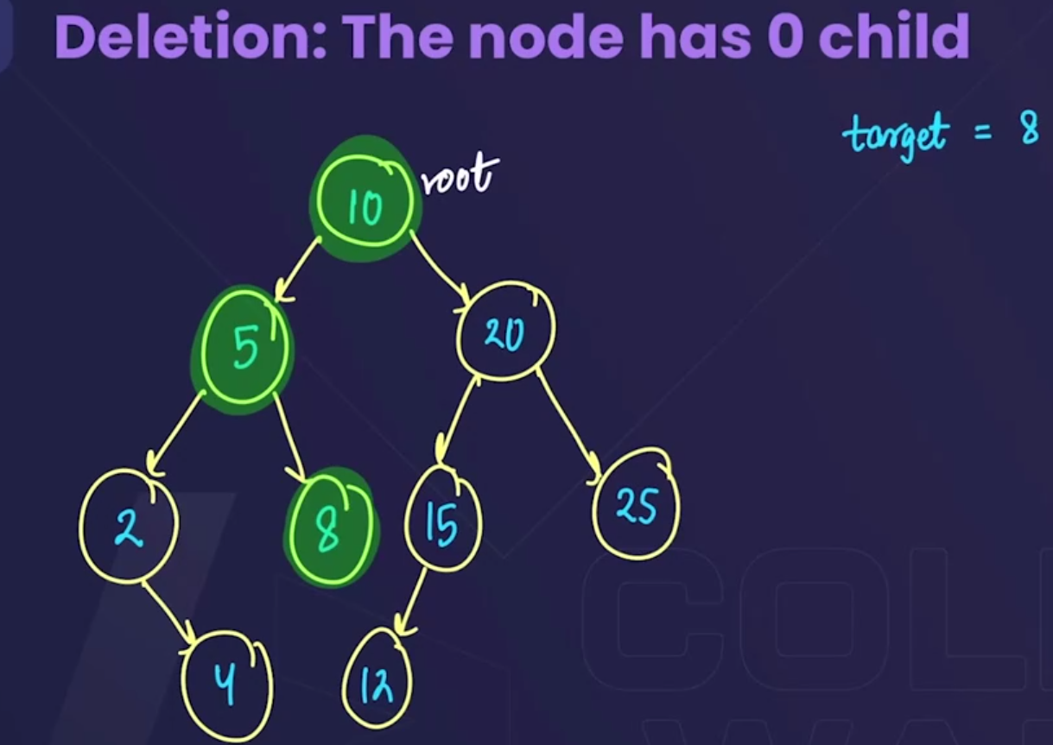🡪directly node ko hta do, koii ar changes krne ka jaroorat nhi h.

**Case 2:🡪node having 1 child** 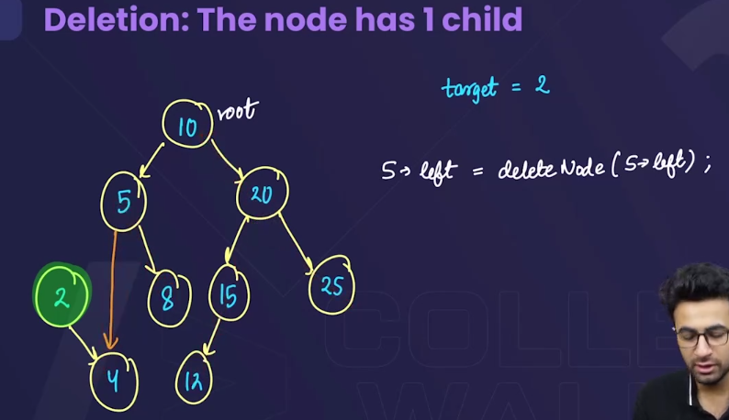🡪isme kchh nhi krna, bs jisko delete krna h uss node se connection hta k, uske child se attach kr do.

**Case 3:🡪node having 2 child**

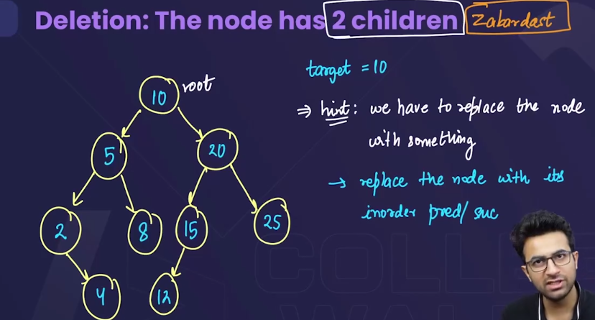

* Can be solved by 2 methods:
  + Either replace the node to be deleted by its inorder predecessor. 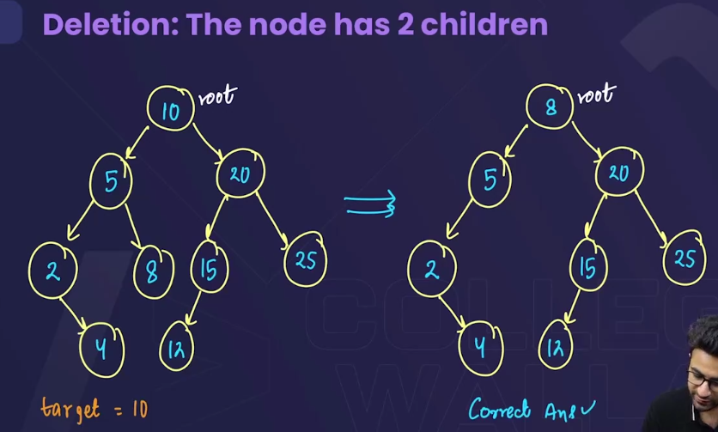
  + Or replace the node to be deleted by its inorder successor. 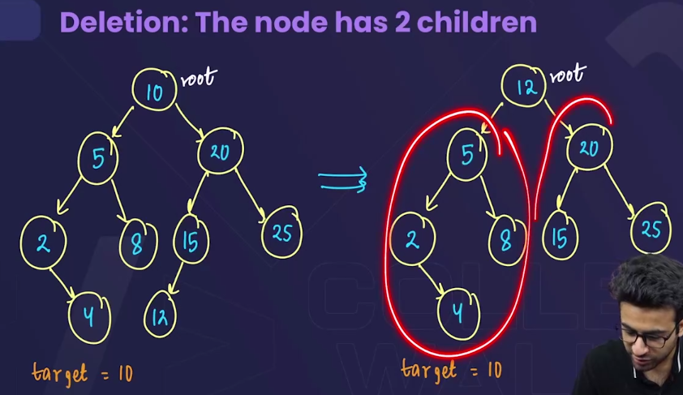
* 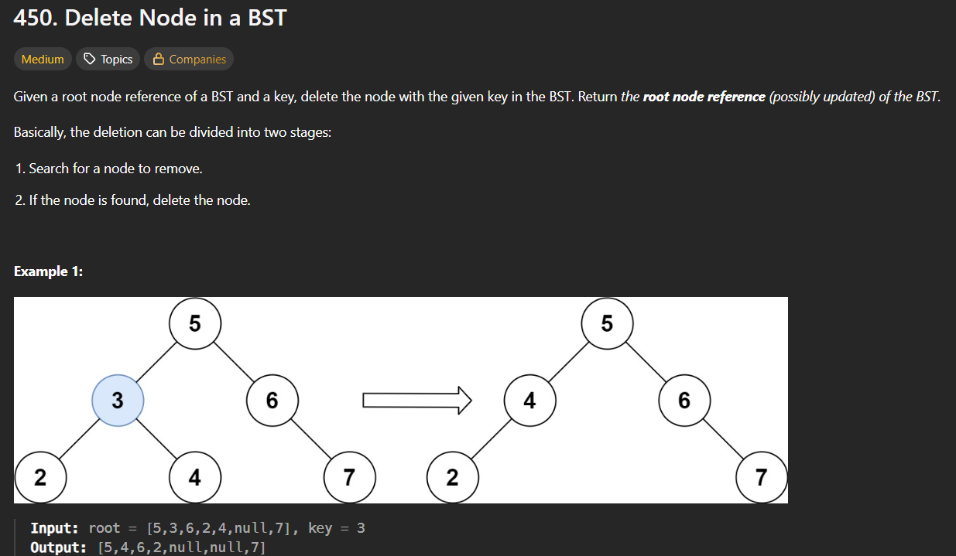 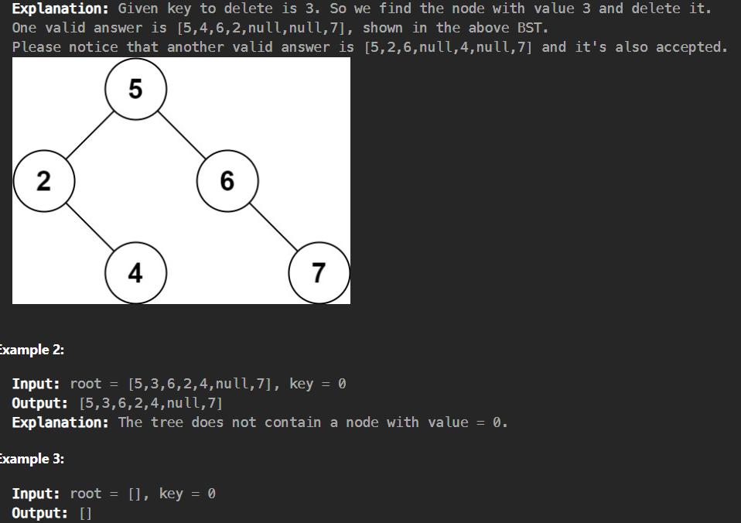

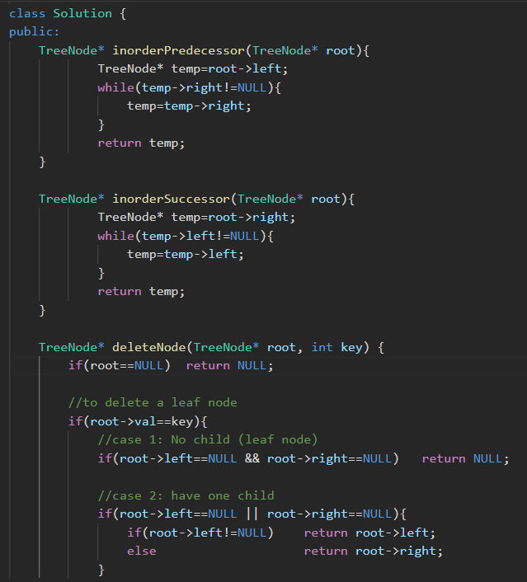

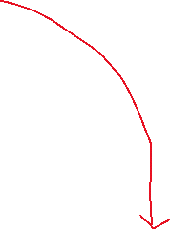

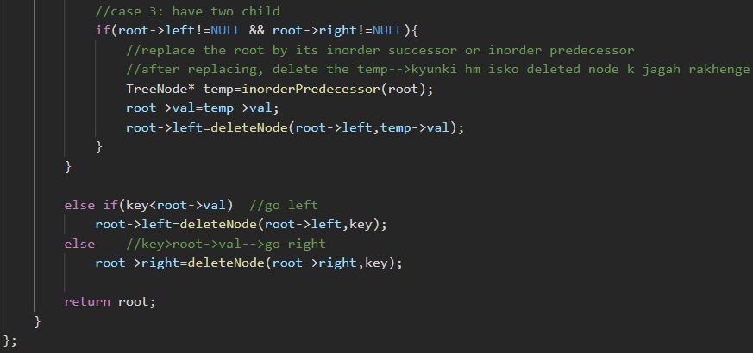🡪use either inorderSuccessor or inorderPredecessor

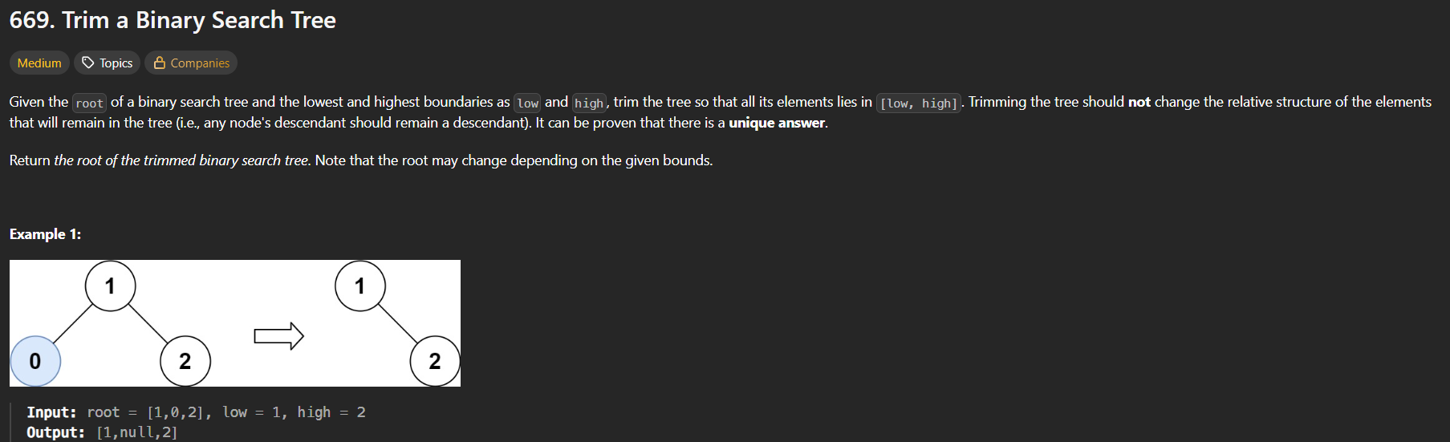 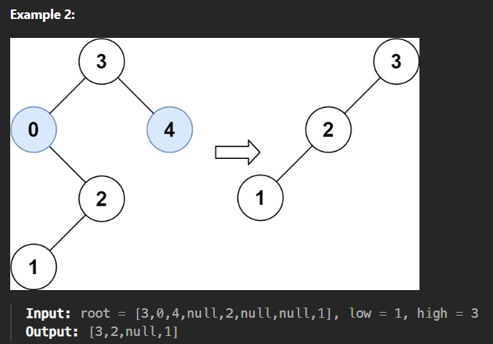

* Iss question m hme “low” and “high” given h, hme low se high k beech k saare numbers ko rakhna h tree m, baaki sbko delete kr dena h. 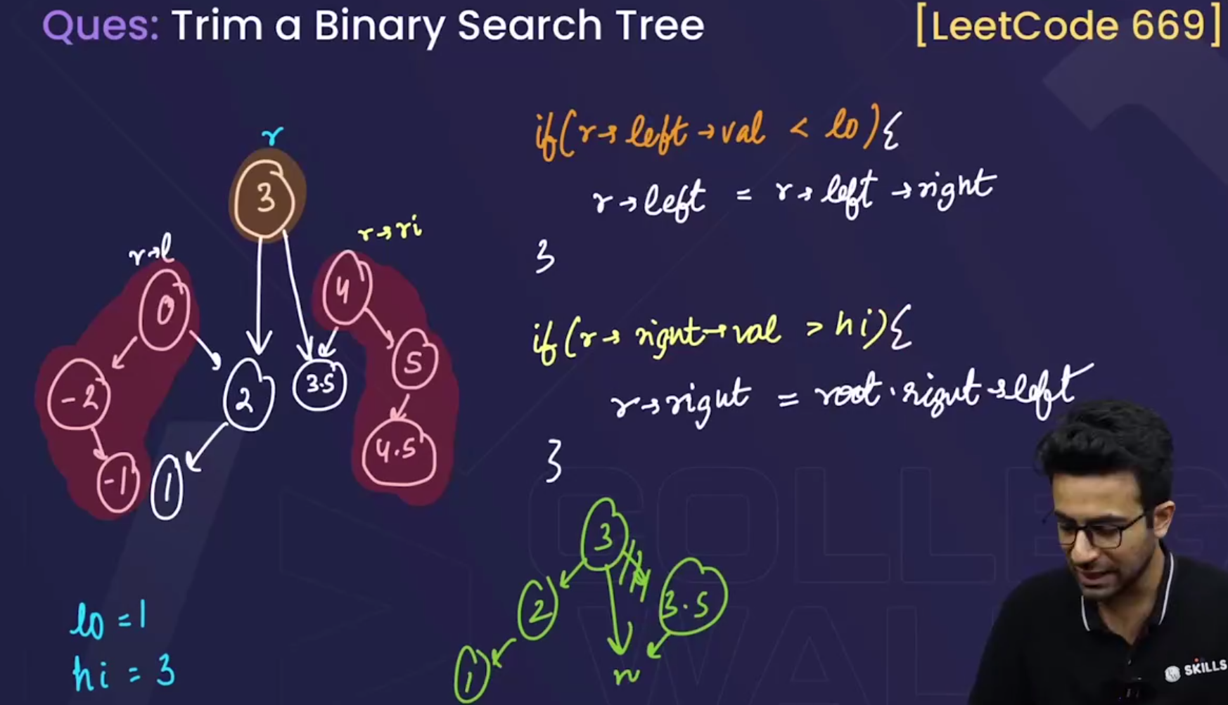

Since in this question low=1, high=3, 🡪so start from the root, then, root🡪left m jaoo, agar woh low se Chhota h, then uske bhi left ka saara value, root se km hi hoga, so root ko , directly root->left ke right m attach kr do, so , isse left waala sb directly delete ho jaayega.

Similarly, right m jaoo, agar woh high se bada h, then uske bhi right ka saara value, root se bada hi hoga, so root ko , directly root->right ke left m attach kr do, so , isse right waala sb directly delete ho jaayega.

* In the above pseudocode, we have not checked the root, that whether it lies in the range or not.
  + So to check the root, we will make a new dummy node, and usko value denge INT_MAX(hm usko INT_MAX value isliye denge taaki root k left m poora tree aa jaaye and right m NULL), and jo hmaara given tree h, usko dummy k left m attach kr denge, and dummy k right m NULL attach kr denge. So isse hme root ko check nhi krna hoga , root automaticall check ho jaayega.
  + Also note that, jb h value return krenge, the root ko return nhi krenge, dummy->left ko return krenge, becoz, dummy ka left hi hmaare actual tree ka root h.
  + 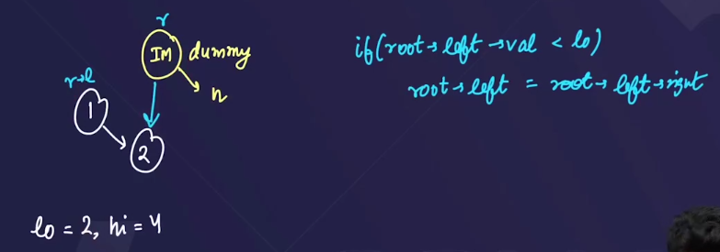
  + Ek aisa bhi case aa skta h, jha root->left, high se bhi bada ho, so in that case, root ko, root->left->left se attach kr do.

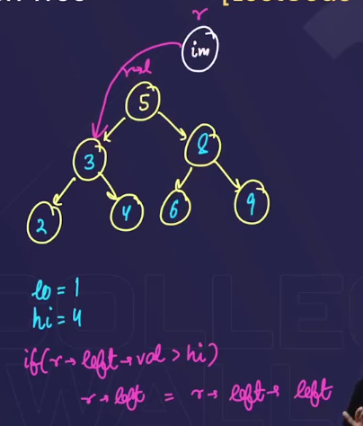

* + Similarly, Ek aisa bhi case aa skta h, jha root->right, low se bhi Chhota ho, so in that case, root ko, root->right ->right se attach kr do.
* 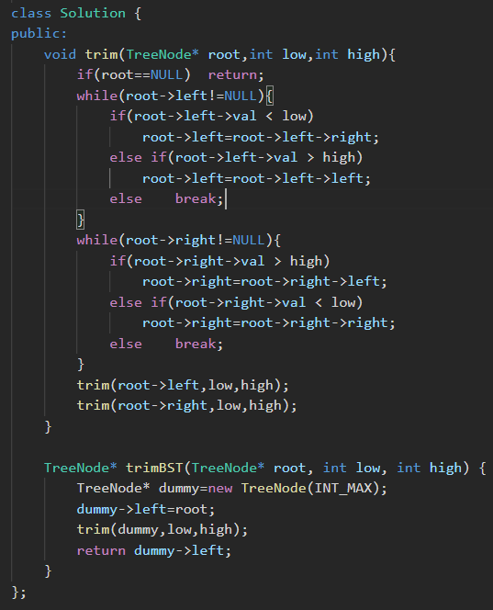

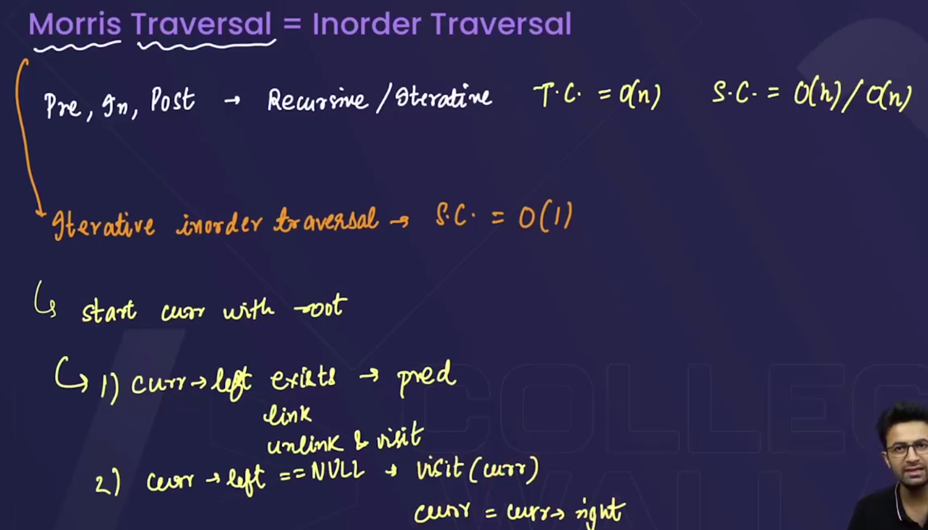

* Morris traversal is used for inorder. We use this traversal method becoz,
  + In the preorder, inorder, postorder traversals
    - time complexity=O(n)
    - space complexity=O(h) or O(n)
  + But Morris traversal is the iterative inorder traversal, that consumes
    - Space complexity=O(1) 🡪i.e it doesent uses any extra space. 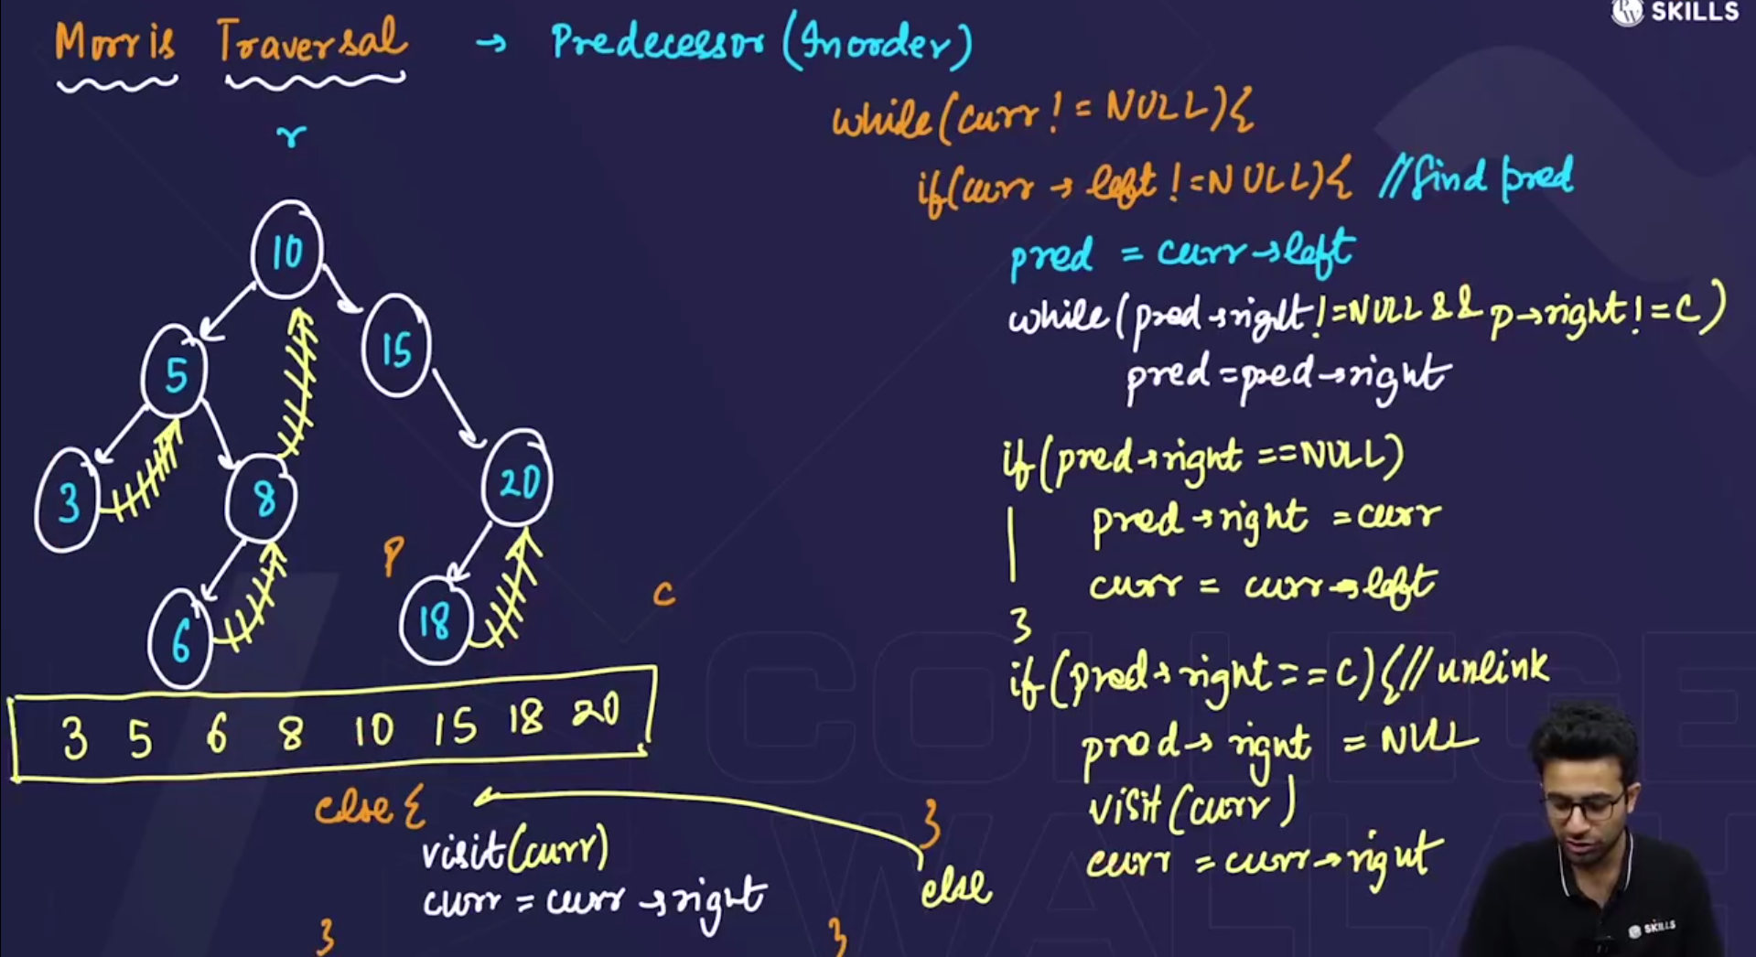 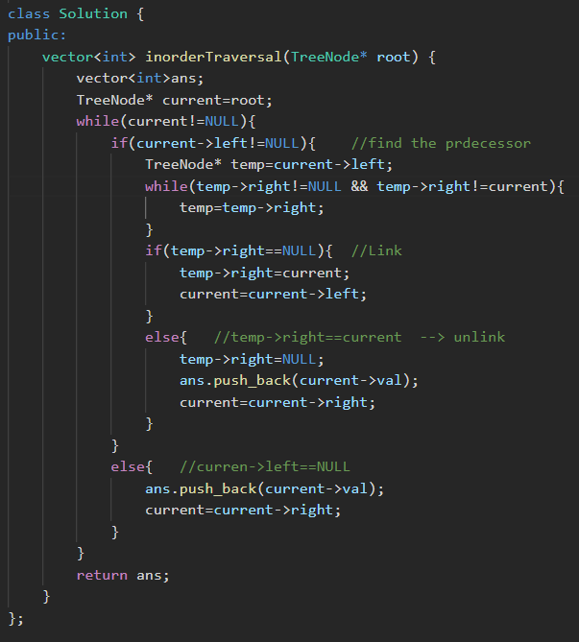🡪leetcode preorder question

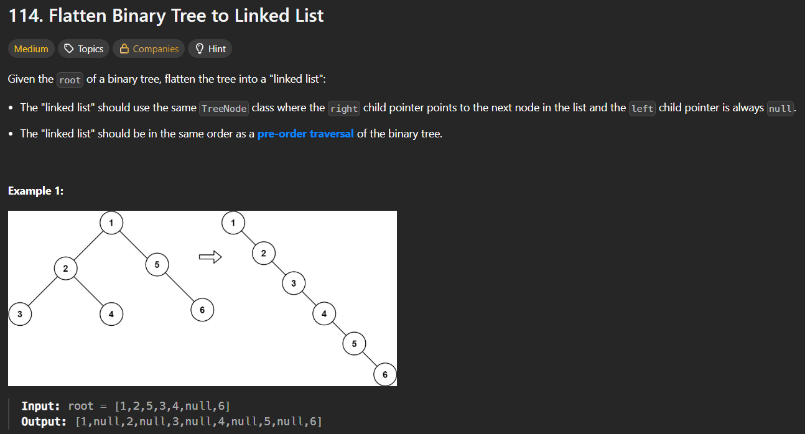 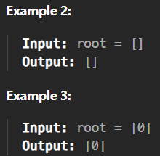

* Method 1🡪using preorder traversal🡪ek vector bnaao, usme preorder traversal ko store kro and then sbke right m ek ek krke attach krte jaoo, and left m NULL attach krte jaoo.
* Time coplexity=O(n) & Space complexity=O(n)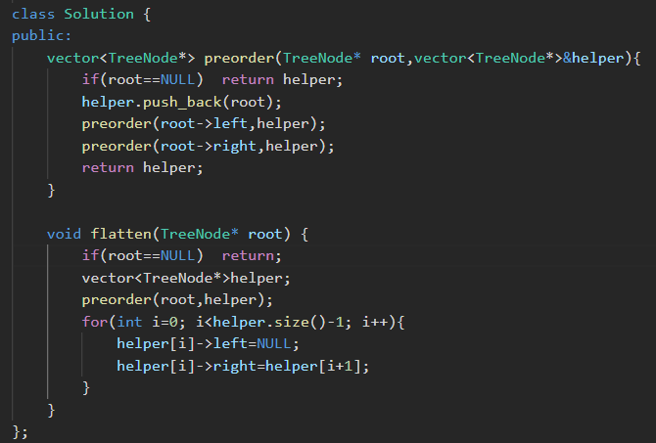
* Method 2🡪using recursion 🡪 Time coplexity=O(n) & Space complexity=O(n)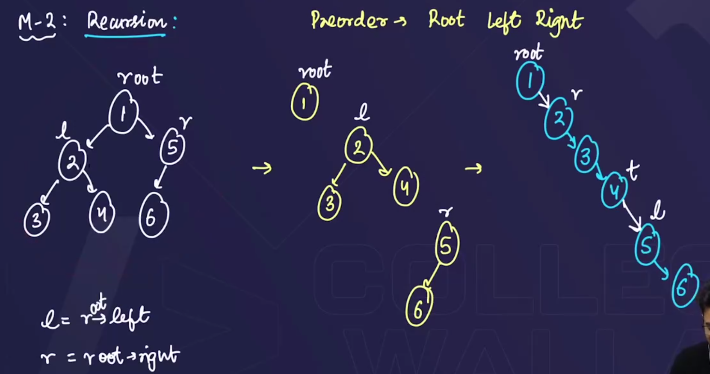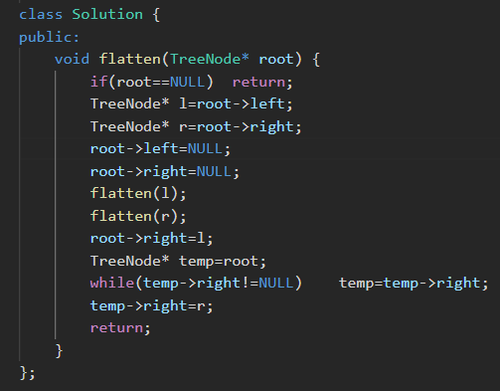
* Method 3🡪Morris traversal:🡪time complexity=o(n) & **space complexity=O(1)**  